1:

Free and featured this April at Cell Press

Filed to [Promoter](http://crosstalk.cell.com/blog/topic/promoter)

http://crosstalk.cell.com/hs-fs/hubfs/Headshots/meghan-gaucher.jpg?t=1478274396864&width=30&height=30&name=meghan-gaucher.jpg Posted by [Meghan Gaucher](http://crosstalk.cell.com/blog/author/meghan-gaucher) | Published April 28, 2016, 10:09

An advancement in generating insulin-producing β cells with promise for helping people with diabetes. Evidence that maternal smoking has irreversible health implications for newborns. The advancement of cancer immunotherapies in cancer research. All of these are research topics freely accessible from [Cell Press](http://www.cell.com/) this month.

**[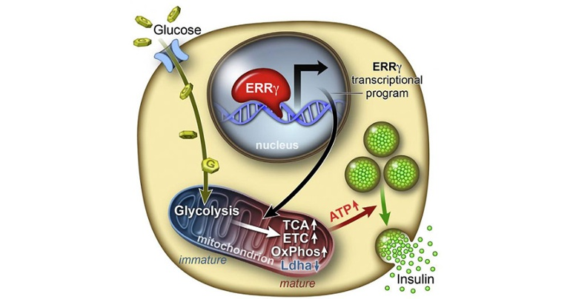](http://www.cell.com/cell-metabolism/fulltext/S1550-4131(16)30108-5)**

**Potential treatment for diabetes is successful in mice**

On April 12, [a paper in *Cell Metabolism*](http://www.cell.com/cell-metabolism/fulltext/S1550-4131(16)30108-5) revealed a new approach for replacing the insulin-secreting β cells lost in type 1 and type 2 diabetes. Scientists at the [Salk Institute](http://www.salk.edu/science/directory/staff-scientists/) can now produce hundreds of human β cells in the lab that are able to reverse diabetes in mice.

The magic ingredient is ERRγ, a protein switch that can turn on the β cells that are not functioning properly in diabetes. The Salk team used pancreatic β cells, generated in the lab via induced pluripotent stem cells (iPSCs), that were able to successfully respond to glucose and produce insulin with the leverage of ERRγ.

"This advance will result in a better controlled insulin response than currently available treatments," says [Michael Downes](http://www.salk.edu/science/directory/staff-scientists/), the co-senior author of the paper and a senior scientist at the Salk Institute. "Previously there was nothing known about the maturation process in β cells. We peeked into that black box, and now we know what's going on."

When the iPSC-created mature β cells were transplanted into diabetic mice, the procedure was able to successfully cure their diabetes. The exciting implication of the study is that the same rescue could be replicated in a clinic on a diabetic human patient, but this is many years away from being tested.

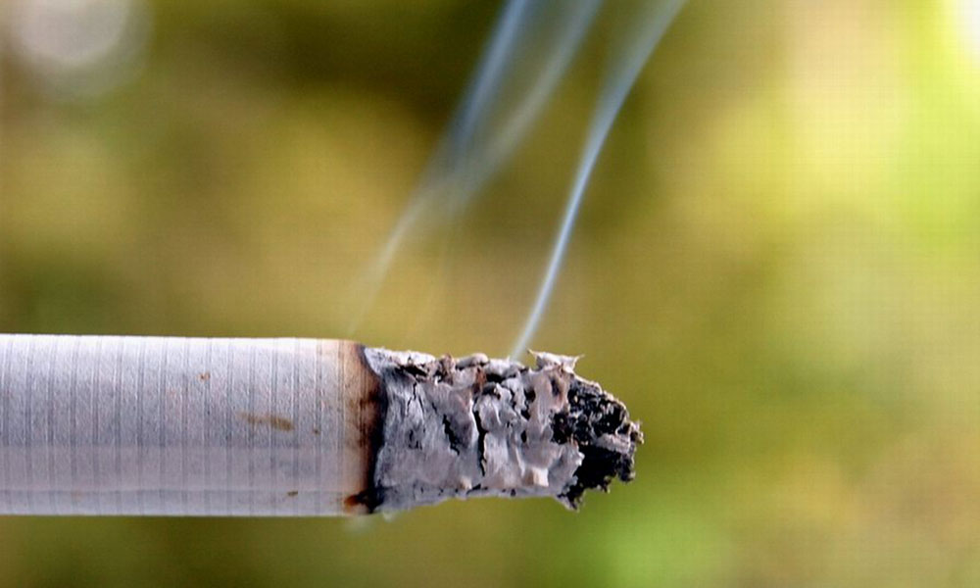

**Health risk alert for fetal DNA: Maternal smoking alters the health of a developing fetus**

Smoking and using tobacco products are highly advertised as exacerbating diseases and common health problems. Links between developing DNA in children and their parents' DNA has been identified in smaller studies, and [a recent study released in](http://www.cell.com/ajhg/fulltext/S0002-9297(16)00070-7)[AJHG](http://www.cell.com/ajhg/fulltext/S0002-9297(16)00070-7) helps confirm that development-related genes are affected by smoking. The data suggest a potential explanation for the link between maternal smoking habits and health complications in children.

An international research team used survey response data from over 6,000 mothers of newborns. The researchers categorized the mothers into smokers and non-smokers, or, to get technical, "sustained smokers" and "any smoking categories." Next, methylation (or DNA markers) was analyzed using blood samples from the umbilical cord after delivery. Results pointed to 6,073 places where DNA was marked in babies born to mothers who identified themselves as sustained smokers through pregnancy. Researchers could directly correlate DNA marks with existing genes associated with many developmental issues, including cleft lips and palates. The research shows that methylation *may*be a direct cause of child development and disease; however, the questions of *how*and *why* are still unknown.

Next steps for the research team at [the National Institute of Environmental Health Sciences](http://www.niehs.nih.gov/) led by [Bonnie  R. Joubert](http://www.niehs.nih.gov/research/supported/dert/phb/joubert/index.cfm)and corresponding author [Stephanie J. London](http://www.niehs.nih.gov/research/atniehs/labs/epi/pi/genetics/) include building on the existing gene analysis to better understand how these DNA modifications might influence child development and disease.

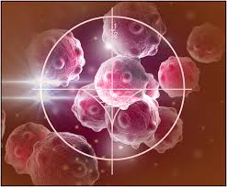**Immunotherapy and the battle against cancer**

A recent [Cell Select article](http://www.cell.com/cell/fulltext/S0092-8674(16)30340-3)explores research, completed at a variety of labs, pointing to different discoveries that could potentially boost the success of immunotherapies. During immune system drug and therapy trials, cancer cells can often trick the immune system, thus resulting in immunotherapy failure and advanced cancer. However, these obstacles have created exciting opportunities for researchers and medical professionals.

The [2010 FDA-approved release of the first therapeutic immunotherapy vaccine, Provenge](http://www.fda.gov/NewsEvents/Newsroom/PressAnnouncements/ucm210174.htm), for advanced prostate cancer, marked a turning point in the research-fueled forward endeavor to develop new immunotherapies to cure different types of cancer. The domino effect of vaccine releases prompted further FDA approval of immunotherapies, [including Yervoy in 2011](http://www.cancer.gov/about-cancer/treatment/drugs/fda-ipilimumab), for the therapeutic treatment of metastatic melanoma. Yervoy was able to successfully block cytotoxic T-lymphocyte-associated protein 4 (CTL4-A), a receptor that negatively regulates the activation of T cells. The clinical triumph of CTL4-A blockade prompted the research and release of other checkpoint molecule-targeting drugs which have recently also been approved by the FDA, including nivolumlab and pembrolizumlab.

The increasing knowledge of cancer, including its biology, prevention, diagnosis, and treatment, has led to a better foundation for further advancing immunotherapy research and available, approved immunotherapies.